Format to report your ADVANCED JAVA PROGRAMMING PROJECTS

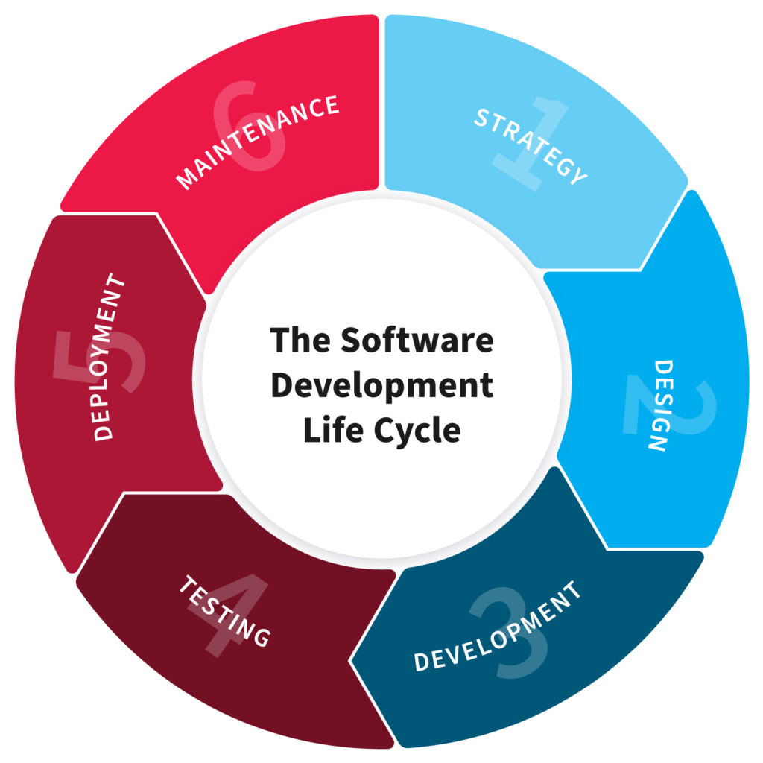

NB: EVERY STUDENTS HAS TO PRODUCE THIS DOC

NAME: RUGWIRO Yves Maurice
REG NO: 221020922
CLASS NO:

PROJECT NAME: Airline Ticket Management System

1.PLANNING

“In this Section, Students, have to define the system ( your projects) goals and objectives and the problems the future system needs to solve.”

Airline ticket management system is the project that is based on airline management system which has been developed using different programming languages like Java and SQL Server.

The main objective for developing the project is to managing flight schedules booking ticket and finally make the payment. It will also manage the important information about the passenger’s reservation, Booking enquiry.
It will time to time current information related to flight schedule and track all details about airline information, ticket booking and passenger information.
This system is expected to work smoothly than the manual system (using notebook and papers to record information) which is very slow, time consuming and money wasting compared to the modern one.

2. Design

“In this Section, students needs to elaborate how the system will work, focusing on software design and how it works with the technical and functional requirements of the system. Depicts also how your team defined how users will interact with the software.”

Our project design phase will demonstrate the user how our system work in order to make it easily to understand it and use it.
It has fuctional and non-fnctional requirement wich are:

Functional requirements:

- Home page: this is page that links different pages of the whole system (passenger, flight, booking and cancellation pages).

- Login page: in this part the user will login using the username and passwords which has been recorded in Data base, here the system will verify and identify the information
Entered by the user if it stored in Database and after that check if the username and passwords entered are the same as stored.

- Passenger page: this page will enable us to some sort of information of customers where we have permission to add new record, update, view, and delete.

- Ticket page: this is the page where we have the ability ticket for the customer in the system of those who already made the reservation of the ticket.

- Cancel ticket page: this is the one of the crucial page where it will enable to cancel the ticket of the customer for the particular reason or circumstances of customer.

- Flight page: this will help us to track the any available flight and their seats number

Non-function requirement of our project:

3. Development

“ In this Section, Students need to elaborate how they build the entire system( Front end- back end technologies), chosen libraries, platforms, storage and databases, adopted technologies, etc...”

In development section of our project we tried to use different back and front-end technologies, in creation of front-end technology, we used Netbeans platform which combined the different elements in our system including pages.
On back-end technology, we adopted Java programming language to combine front-end design to local storage so as to store the data from the user interface.

Libraries: Mysql-connector, jCalender, r2mxl.jar
Platform: NetBeans application
Storage and database: MySQL
Server: Xampp
Main tools: Computer and network.

4.Testing

“ In this Section, Students to show the way this stage was conducted. Ensuring that everything works as expected. Which defects and bugs you found, and how did you fixed them to ensure that the product meets the original specifications.”

In this testing section is conducted with the purpose of evaluating and verifying that our project will perform how it is supposed to do. And it also help to identify the bugs and errors early, so that they can be fixed before the project is delivered or used.

STAGES THAT USED TO TEST THE PROJECT

- Unit testing: the main is to isolate the written code and determine if it works as intended.

- Integration testing: this phase in testing in which individual software modules are combined and tested as the group.

- System testing: testing that is performed on complete integrated system to evaluate the compliance system with the corespondance of requirements.

- Performance testing: the goal include evaluating the project output, processing speed, data transfer, memory utilization.

5.Deployment

“ In this Section, Students have to describe how, installation, testing, deployment, and performance monitoring were conducted in their own respective laptop or desktop . “

In this section of development which is the last step in software development life cycle it is also phase of planning, creating, testing and deploying information system across hardware and software.

It also consists of installing different platforms with the goal of checking how it will perform and provide some trainings to the users.

Here are some platforms we used to install our project which are:

- Java development kit(JDK)
- NetBeans platform
- MySQL-connector libraries,
- jCalendar libraries
- r2mxl libraries
- Xampp server
- MySQL databases

